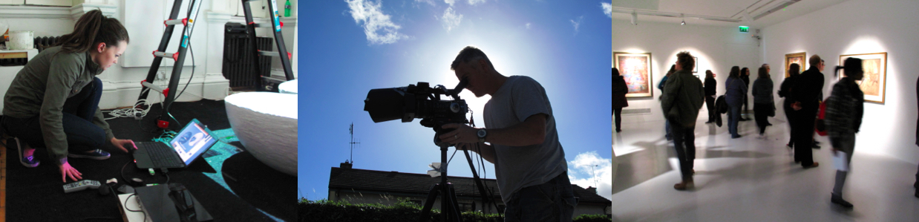

PORTFOLIO & REMOTE VISUAL CREATIVE TEST GUIDELINES FOR APPLICATION TO

BA (Hons) in Art CW038 (4 year course) BA in Art CW057 (3 year course)

You can now a make digital submission in TWO ways

- Submit your Portfolio as a Digital Portfolio via email to artportfolio@itcarlow.ie
or
- Submit for a Remote Visual Creative Test to be completed in 3hours over 2days

You can submit by either option up to 1st June 2020. Your work will be assessed within 7 days and an assessment result will also be issued.

CAO Late applicants or Change of Mind applicants should make contact with the Wexford Campus prior to making a submission.

DIGITAL PORTFOLIO or REMOTE VISUAL CREATIVE TEST OPTION
The Portfolio or Remote Visual Creative Test outcome is on a pass/fail basis of which applicants will be informed. Please note that formal CAO offers will only be issued for the highest CAO course preference for which you are deemed eligible. These offers will be issued to eligible applicants by CAO and will be based on your highest preference as at 1st July 2020.

Leaving Certificate OR QQI-FET Applicants: Eligible Applicants must have successfully completed the portfolio assessment or test and meet the course Eligibility requirements for Leaving Certificate OR QQI-FET. Mature Applicants: Eligible Applicants must have successfully completed the portfolio assessment or test and the Mature Applicant Selection Assessment.

DIGITAL PORTFOLIO SUBMISSION VIA EMAIL

You can submit your portfolio via email to artportfolio@itcarlow.ie
You must include applicants name, address, phone number, email address and CAO number.

No more than 20 IMAGES should be included.
These can be included as jpgs in a Microsoft Word document, as a PowerPoint presentation, as a pdf or as jpegs attached to your email.

Images can also be hosted on a publicly available image-sharing service such as Instagram or Flickr,
These images must be publically viewable without any password or login needed.

The link should be tested in advance from another computer and email address
You can also include videos via a link to a hosting service such as YouTube, or Vimeo

You can take photos of your artwork in a well-lit area or outdoors using most automatic digital cameras or camera phones. Simple presentation of your work on white background is preferable.

Digital Tips for email submission.
Do not insert video files or links in a PowerPoint. Instead include any ‘hyperlinks’ in the text of your email.

The total file size of your email submission should not be greater than 20mb.
Managing images sizes: Changing dimensions will help to keep the file size smaller. Jpg should not be larger than 1mb. One way to make the file size smaller is to compress or resize the image to a lower resolution. You can also ‘Save as ‘ or ‘Rename’ jpgs to a smaller file size. MS Lens is a useful free phone app that will allow you combine many photos into a pdf and send from a smartphone

REMOTE VISUAL CREATIVE TEST OPTION
To request the option to do a visual test if your portfolio work is not available to submit as a Digital portfolio due to Covid 19 you can choose to do a Remote Visual Creative Test instead.
Email a request to avail of this option with your CAO number and details and a visual test will be sent to you by 5pm that day and you will be required to submit your work by 5pm two days hence. 48hrs
Please email artportfolio@itcarlow.ie for the test task to be sent to.
You will be required to make 3 pieces of creative work over two days and submit photographs of these. You should not need to spend more than 1 hour on each task. You will be required to declare that the work is made by you. A smartphone is suitable for doing this.

If you have any queries regarding the above information, you can contact us on email:artportfolio@itcarlow.ie

Portfolio Content
Your portfolio can include work done in school, at home or from any classes you have attended over the past number of years. If you study art in school, you may already have quite a lot of work that you can include in your portfolio. If you are not studying art in school, you will still be able to prepare a portfolio.

You will see suggestions below but remember we don’t expect you to be an expert at this stage - what we mostly want to see is that you are creative and prepared to try different methods of art making. Drawing is a great way to demonstrate your skills and we are also interested in seeing your creative thought patterns demonstrated in a variety of ways. As well as what you see in the list you could include any visual documentation (photos) of any special interests you have that are visual or involves making.

Drawing forms an important part of most portfolios and the following general categories of study may help you think about a way to work at a possible section to your portfolio. Work from each section is not necessarily expected.

- – Drawing Studies of figure / head / life drawing.
- – Drawing Studies of man-made structures.
- – Drawing Studies of natural / organic / living structures.
- – Drawing Studies from the environment around you / urban man-made

Carefully observed drawings, colour studies, print or 3D studies that fully explore the attributes of some particular subject matter that interests you.

Photographs can be submitted as images in their own right. They may be part of general research in sketchbooks, worksheets, or as documentation of three-dimensional work.

Portfolio Presentation Tips
No more than 20 PIECES presented flat within one portfolio cover.
A simple way to prepare a portfolio is to layout your work on A2 paper sheets.

Collections of small or related images can be laid on each sheet.
e.g. photographs or smaller drawings can be mounted together.

Simple presentation of your work on white paper is recommended. Mounting is not necessary.

You can also include notebooks, worksheets, scrapbooks and development sheets.
Photographs of three-dimensional and very large works may be included.

Remember the visual research leading to the finished work in your project assignments is as important as the finished work. We are particularly interested in seeing your creative thought patterns.

Portfolios must be clearly marked with the applicant’s name, address, phone number, email address and CAO number on the top left-hand corner, both inside and outside. Each individual piece in the portfolio (including sketchbooks) must also be marked with the applicant’s name, address and CAO number.

